**A.I Manual By Saqib Hussain**

**Roll no:BIT-23F_014**

**Lab no 7**

**Task 1: Multiply Two Numbers**

Function:  
def multiply(a, b):  
 return a * b  
  
result = multiply(4, 5)  
print("Product:", result)  
  
Output:  
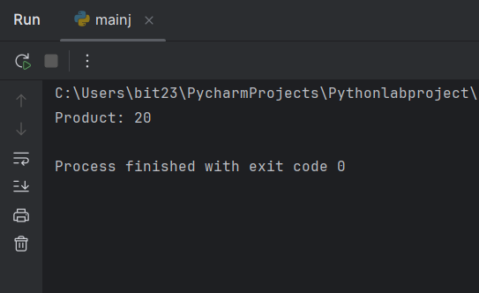

**Task 2: Check Even or Odd**

Function:  
def check_even_odd(number):  
 if number % 2 == 0:  
 return "Even"  
 else:  
 return "Odd"  
status = check_even_odd(7)  
print("Number is:", status)  
  
Output:  
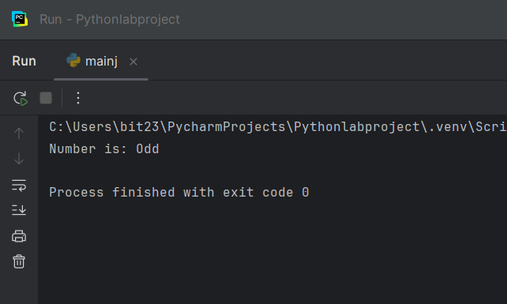

**Task 3: Greet with Name and Age**

Function:  
def greet(name, age):  
 print(f"Hello, {name}! You are {age} years old.")  
  
greet("Alice", 30)  
  
Output:  
